Adam Heitzman

ISTA 131

Final Project Images

**GITHUB LINK:** <https://github.com/pyrogenix/131_finalproject>

**Image 1:** Run **adam_visualization1.py**, and input ‘1’ when prompted to produce the following image:

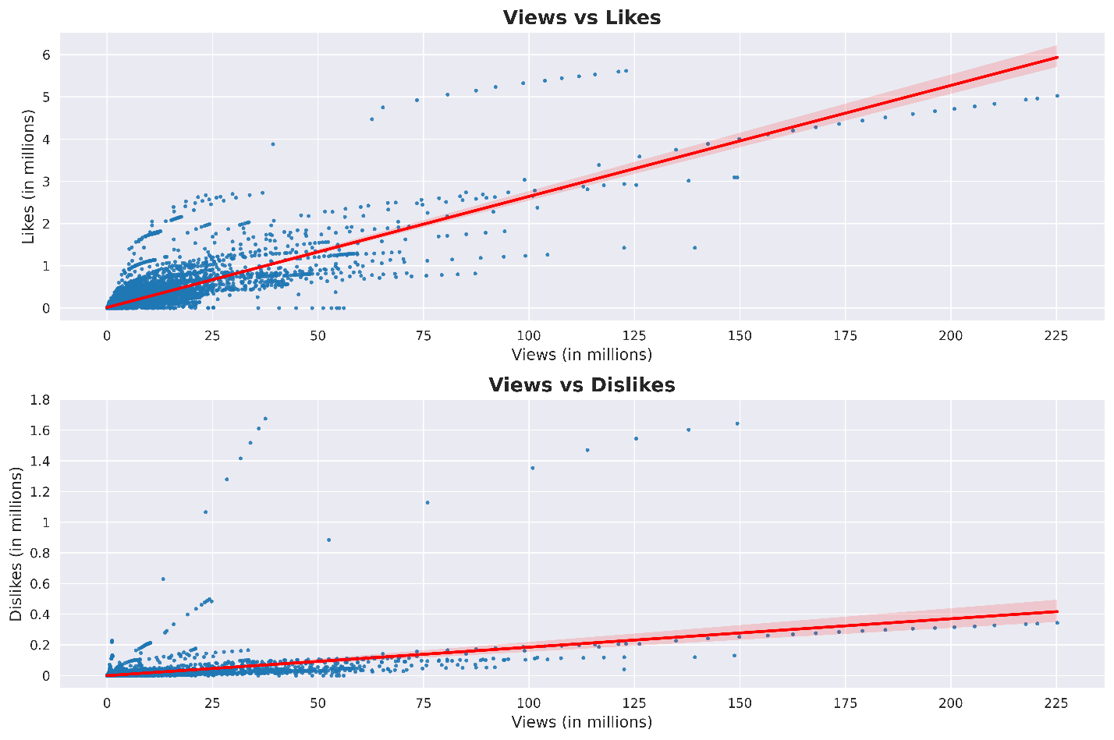

**See next page for Image 2.**

**Image 2:** Run **adam_visualization2.py to** produce the following image:

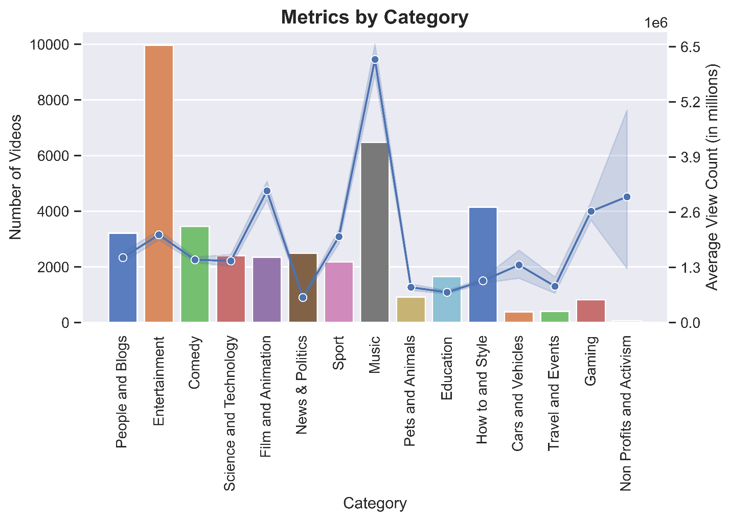

**See next page for Image 3.**

**Image 3:** Run **adam_visualization3.py to** produce the following image:

